Bethany Center Community Learning Program Evaluation
Report by Aaron Hagedorn, PhD.
A series of thought-provoking seminars were hosted by the Front Porch Center for Innovation and Well-being between June-November of 2021. The workshops included a focus on Dementia and Brain Health hosted on 6/24/21, Hoarding and Decluttering hosted in 7/2021, Depression hosted on 8/26/21, Alcohol use disorder hosted on 9/30/21 and sleep hosted on 11/18/21.
Bethany Center offered the workshops in English and Cantonese to all residents as a social event with guest speakers from outside the community. This new form of livestreamed educational content was meant to serve the dual role of educate and encourage socialization after months of social distancing and lockdowns.
Evaluation surveys were provided after each session. The following report summarizes the results.
All five seminars proved to be very popular, though the most valuable sessions rated a vary valuable by the participants were Hoarding (65.5%), Alcohol use disorder (65.2%), Sleep (61.9%) and Depression (60%). The first seminar focused on dementia was rated as very valuable by only 52% of the participants and had the most people who didn’t find value in it (12%). The nature of the topic may interest only those with direct contact with those facing dementia and could be seen as depressing for those who attended just for the opportunity to socialize. While dementia was the least popular topic, all other events, had between 1-4 participants out of about 25 who couldn’t fully relate to the topic, except for sleep which no one found unrelatable. These results can reflect the relevance of the topic, the quality of the content and their perception of the presenter.
Was the presentation topic valuable? (1: Not at all valuable; 5: Very valuable)
 | Dementia | Hoarding | Depression | Alcohol | Sleep
Not at all valuable | 3 | 1 | 3 | 0 | 0
A little valuable | 1 | 0 | 1 | 2 | 0
Somewhat valuable | 2 | 2 | 0 | 1 | 0
Valuable | 6 | 7 | 6 | 5 | 8
Very valuable | 13 | 19 | 15 | 15 | 13
nonresponse |  |  |  |  | 1
Total Participants | 25 | 29 | 25 | 23 | 22
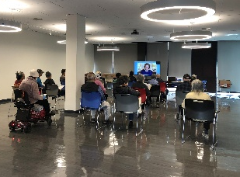
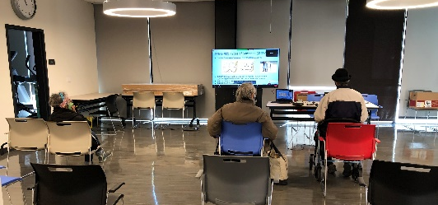
Observations about the Dementia Workshop
An analysis of the distribution of the data reveals an interesting pattern. The mean scores of 4.0 with a standard deviation of 1,29 suggests that scores below 2.7 are beyond 2 standard deviations from the mean, and therefore can be considered as outliers. An analysis of the outliers who found it unhelpful discovered they also scored it as highly satisfied overall, and they would like more presentations like this. While many participants reported that they made new friends or reacquainted with old friends, those who said the workshop was not valuable in fact said they did not meet any friends. Once could reasonably infer that these participants did not gain the social benefit of attendance, as the majority who reported being among friends might have. There was a very strong pattern of those reporting the event as leading to meeting or strengthening friendships reporting higher satisfaction with the presentation.
Observations about the Hoarding Workshop
An analysis of the distribution of the data reveals an interesting pattern. The mean scores of 4.48 with a standard deviation of 0.90 suggests that scores below 2.7 are beyond 2 standard deviations from the mean, and therefore can be considered as outliers, and below 3.6 are also outside the normal range . An analysis of the 3 outliers who found it unhelpful found that they reported feeling lonely (2 responded that the did not know how they felt), while all 3 also reported that they had not engaged with any friends at the event. They did suggest future events would be helpful. A total of 11 people found it helpful, while 6 did not; but only 1 person said they didn’t want to attend similar events in the future. The only had written open ended response was “This topic is so important, you can get different ideas for cleanliness and for (illegible ) especially to your (illegible) or if you have any (illegible) “ This suggests that many people could relate to this topic, even if they didn’t know anyone directly affected.
Observations about the Depression Workshop
An analysis of the distribution of the data reveals an interesting pattern. The mean scores of 4.16 with a standard deviation of 1.35 suggests that scores below 1.56 are beyond 2 standard deviations from the mean, and therefore can be considered as outliers. An analysis of the only outlier who found it unhelpful found that person reported feeling lonely, while also not engaging with any friends at the event, and they didn’t respond to the question about whether or not the event was helpful. A total of 11 people found it helpful, while 6 did not; but only 1 person said they didn’t want to attend similar events in the future. The only had written open ended response was
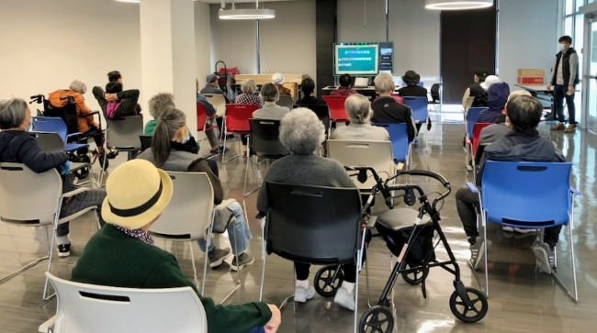

Observations about the Alcohol use disorder workshop
The meeting on Alcohol Use Disorder brought together 23 participants. The mean satisfaction score was 4.43, with a standard deviation of 0.92, thus any score below 2.63 falls more than 2 standard deviations from the mean. There were 2 participants who didn’t find the topic valuable or helpful to them, though both suggested they wanted to see more workshops like that in the future, and both reported feeling lonely, and that the event made them feel less lonely, and both reported that they would suggest the workshop to a neighbor.
Observations about the Sleep workshop
The meeting on depression brought together 21 residents, and everyone felt it was valuable. Only 2 people felt it may not have been helpful, though they did not elaborate on any reason, and they both found the gathering as a social opportunity to connect with friends. Sleep patterns change with age, making this topic uniquely valuable to a older adult.
Summary of the results for helpfulness of the topic
Overwhelmingly participants agreed that the sessions were very helpful and rated the very helpful sessions as: Alcohol use (82.6%), Sleep (71.4%), depression (68%), hoarding (65.5%), and dementia (52%). Only 1 or 2 participants in the dementia, hoarding and alcohol use workshops found it not helpful to them personally. While these topics may not affect everyone, each of these topics could dominate ones life if they are affected.
How helpful was the presentation? (1: Not at all helpful ; 5: Very helpful)
 | Dementia | Hoarding | Depression | Alcohol | Sleep
Not at all helpful | 2 | 1 | 0 | 2 | 0
A little helpful | 0 | 0 | 1 | 0 | 0
Somewhat helpful | 3 | 2 | 1 | 1 | 2
Helpful | 7 | 7 | 6 | 1 | 4
Very helpful | 13 | 19 | 17 | 19 | 15
nonresponse |  |  |  |  | 1
Total | 25 | 29 | 25 | 23 | 22

Participants were extraordinarily satisfied with the presentations, with 72% reporting they were very satisfied with the presentations on Dementia and Depression, 62% very satisfied with the hoarding presentation, 60.9% very satisfied with the Alcohol use disorder presentation and 47.6% very satisfied with the sleep presentation. Across all 5 presentations, only 3 respondents out of 123 total respondents reported being not fully satisfied with the presentation.

How satisfied were you of the presentation as a whole? (1: Not at all satisfied; 5: Very satisfied)
 | Dementia | Hoarding | Depression | Alcohol | Sleep
Not at all satisfied | 0 | 1 | 0 | 0 | 0
A little satisfied | 0 | 2 | 0 | 2 | 0
Somewhat satisfied | 4 | 0 | 2 | 1 | 2
Satisfied | 3 | 8 | 5 | 6 | 9
Very satisfied | 18 | 18 | 18 | 14 | 10
nonresponse |  |  |  |  | 1
Total | 25 | 29 | 25 | 23 | 22

When asked ‘Would you like more presentations like this in the future?” there was near universal agreement. For the depression and AUSD topics 100% of respondents agreed to more similar presentations. In the hoarding and sleep topics only 1 participant said no, and 2 non-responses to the dementia topic. This strongly suggests that the format of the presentation was well received by the participants.
Would you like more presentations like this in the future?
 | Dementia | Hoarding | Depression | Alcohol | Sleep
Yes | 23 | 27 | 25 | 23 | 20
No | 0 | 1 | 0 | 0 | 1
I don't know | 2 | 1 | 0 | 0 | 0
nonresponse |  |  |  |  | 1
Total | 25 | 29 | 25 | 23 | 22

To the question “Is it important to have free counseling?” there was universal agreement for most sessions, though 1-3 people dissented with the idea in each session, likely associated with the issue of the week not directly affected them personally.
Is it important to you and the community to have free counseling services available?
 | Dementia | Hoarding | Depression | Alcohol | Sleep
Yes | 24 | 29 | 25 | 22 | 20
No | 0 | 0 | 0 | 0 | 0
I don't know | 1 | 0 | 0 | 1 | 1
nonresponse | 0 | 0 | 0 | 0 | 1
Total | 25 | 29 | 25 | 23 | 22

To the question “Did you make new friends or strengthen old friendships at this event, there was again near universal agreement, with 76% agreeing in the first session on dementia, 86.2% in the second session on hoarding, 88% during the depression talk, 95.7% in the AUSD event and 95% in the sleep talk.
Did you make new friends or strengthen old friendships at this event?
 | Dementia | Hoarding | Depression | Alcohol | Sleep
Yes | 19 | 25 | 22 | 22 | 19
No | 3 | 1 | 3 | 1 | 1
I don't know | 1 | 3 | 0 | 0 | 0
nonresponse | 2 | 0 | 0 | 0 | 2
Total | 25 | 29 | 25 | 23 | 22

One of the main purposes of this even was to address loneliness. In the first event, 30% of participants said they felt lonely (with 5 not answering the questions), in the second event 62% agreed they were lonely (with 8 not responding). In the third event 57% (4 no response), fourth 33% (1 not responding) and fifth 63% (4 non responding). While each event attracted a different group, and one might consider the non-response to be more likely to be lonely; it appeared that about half of participants did in fact experience loneliness despite living in an apartment complex with access to many neighbors.
Do you ever feel lonely?
 | Dementia | Hoarding | Depression | Alcohol | Sleep
Yes | 6 | 13 | 12 | 7 | 10
No | 14 | 8 | 9 | 14 | 6
I don't know | 5 | 8 | 4 | 1 | 4
nonresponse |  |  |  | 1 | 2
Total | 25 | 29 | 25 | 23 | 22

In response to the question Did this event help you feel less lonely, responses were more varied. At the first workshop 72% of respondents agreed (with 7 non-response), 67% at the second (with 10 nonresponse). 72% at the third, with 2 non-response, 59% at the fourth (with 1 nonresponse) and 83% at the fifth (with 2 nonresponse).
Q8. Did this event help you feel less lonely?
 | Dementia | Hoarding | Depression | Alcohol | Sleep
Yes | 13 | 12 | 16 | 13 | 14
No | 5 | 6 | 6 | 9 | 3
I don't know | 5 | 10 | 2 | 1 | 2
nonresponse | 2 | 1 | 1 | 0 | 3
Total | 25 | 29 | 25 | 23 | 22

In response to “Would you suggest this workshop to a neighbor?” participants seemed to largely agree. At the first workshop, which was the least popular, 24 people responded yes and 1 I don’t know. At the second workshop 100% of the 29 participants agreed. At the third workshop, 23 people responded ye and 2 I don’t know; at the fourth workshop 22 responded yes and 1 I don’t know, and the fifth workshop we had 19 people respond yes, 1 no, and 1 I don’t know.
Would you suggest this workshop to a neighbor?
 | Dementia | Hoarding | Depression | Alcohol | Sleep
Yes | 24 | 29 | 23 | 22 | 19
No | 0 | 0 | 0 | 0 | 1
I don't know | 1 | 0 | 2 | 1 | 1
Total | 25 | 29 | 25 | 23 | 22

In conclusion, the Bethany Center workshops were perceived as highly valuable by nearly all participants and seen as a tool for making or reinforcing friendships withing a community where loneliness is very common. Some of the topics may have had a more narrow appeal than others, however, none of them stood out as not helpful, and there was essentially universal agreement that their neighbors would enjoy the workshops as well. The number of participants was fairly stable and it is difficult to attribute any attendance numbers to the vale of the workshop, and time conflicts or differences in advertising of each workshop could impact attendance, in addition to perception of the value of the topic a priori to potential participants.
