Bethany Center iPad Use Survey

Please take a moment to fill out this short survey before checking out your iPad. Thank you!

Date: _________________________ Unit # ________________

- How are you feeling today? (1: Very depressed ; 5: Very happy) Please circle one:

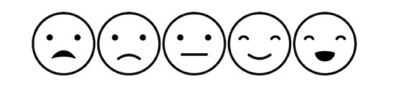
1 2 3 4 5

- What would you like to use the iPad for? (Please check all that apply)

- Games and puzzles
- Talking with family or friends
- Talking with a health provider
- Using the internet
- Other __________________________________

- How often do you feel that you lack companionship? (Please circle one):

Hardly Ever Some of the Time Often

- How often do you feel left out? (Please circle one):

Hardly Ever Some of the Time Often

- How often do you feel isolated from others? (Please circle one):

Hardly Ever Some of the Time Often

- Do you expect the iPad will change your mood? (Please circle one): Yes / No

